# CANTEEN MANAGEMENT SYSTEM



**UNIVERSITY OF ENGINEERING**

# & MANAGEMENT, JAIPUR

## CANTEEN MANAGEMENT SYSTEM

Submitted in the partial fulfillment of the degree of

## BACHELOR OF TECHNOLOGY

in

## COMPUTER SCIENCE & ENGINEERING

under

## UNIVERSITY OF ENGINEERING & MANAGEMENT, JAIPUR

BY

## Swapan Kumar Shee University Enrollment No.12021002001009

**Registration No. 204202100200014**

**Shivam Kumar Mishra University Enrollment. No.12021002001042**

## Registration No. 204202100200046

UNDER THE GUIDANCE OF

## Prof. Jyoti Khandelwal

COMPUTER SCIENCE & ENGINEERING



UNIVERSITY OF ENGINEERING & MANAGEMENT, JAIPUR

**Approval Certificate**

This is to certify that the project report entitled “**CANTEEN MANAGEMENT SYSTEM”** submitted by **Swapan Kumar Shee (Roll:12021002001009) & Shivam Kumar Mishra (Roll:12021002001042)** in partial fulfillment of the requirements of the degree of **Bachelor of Technology** in **Computer Science & Engineering** from University **of Engineering and Management, Jaipur** was carried out in a systematic and procedural manner to the best of our knowledge. It is a bona fide work of the candidate and was carried out under our supervision and guidance during the academic session of 2021- 2025.

### Prof. Jyoti Khandelwal

Project Guide, Assistant Professor (CSE) UEM, JAIPUR

### Prof. Mrinal Kanti Sarkar Prof. A Mukherjee

HOD (CSE) Dean

UEM, JAIPUR UEM, JAIPUR

# ACKNOWLEDGEMENT

The endless thanks go to Lord Almighty for all the blessings he has showered on us, which has enabled us to write this last note in my research work. During the period of our research, as in the rest of my life, we have been blessed by Almighty with some extraordinary people who have spun a web of support around us. Words can never be enough to express how grateful I am to those incredible people in my life who made this thesis possible. I would like to thank them for making my time during my research in the Institute a period I will treasure. I am deeply indebted to my research supervisor, Professor Jyoti Khandelwal for such an interesting thesis topic. Each meeting with her added invaluable aspects to the implementation and broadened my perspective. She has guided us with his invaluable suggestions, lightened up the way in my darkest times, and encouraged me a lot in academic life.

# ABSTRACT

The purpose of Canteen Management System is to automate the existing manual system by the help of computerized equipment and full-fledged computer software, fulfilling their requirements, so that their valuable data/information can be stored for a longer period with easy accessing and manipulation of the same. The required software and hardware are easily available and easy to work with. Canteen Management System, as described above, can lead to error free, secure, reliable and fast management system. It can assist the user to concentrate on their other activities rather to concentrate on the record keeping. Thus, it will help organization in better utilization of resources. The organization can maintain computerized records without redundant entries. That means that one need not be distracted by information that is not relevant, while being able to reach the information. The aim is to automate its existing manual system by the help of computerized equipment and full-fledged computer software, fulfilling their requirements, so that their valuable data/information can be stored for a longer period with easy accessing and manipulation of the same. Basically, the project describes how to manage for good performance and better services for the clients.

# TABLE OF CONTENT

TABLE OF CONTENTS 1

1. INTRODUCTION 2
   1. REQUIREMENT 2
2. LITERATURE REVIEW 3
3. PROPOSED MODEL 4
4. OBJECTIVE &SCOPE OF THE PROJECT 5
   1. OBJECTIVE
   2. SCOPE OF THE PROJECT
5. RESULT 6
6. CONCLUSION AND FUTURE SCOPE 11
7. REFERENCES 12

**CHAPTER 1.**

**INTRODUCTION**

Canteen management system is to provide fast services to their college students, Staffs etc. Usually, People have to go to canteen and order the foods and they have to wait in queue for a long time to get the orders, but with the help of this you just have to follow a very simple process to order your stuffs. And you need not to wait in the long queue. A canteen facility is a supplementary system that is provided by organizations for their employees/students.

Organizations with large numbers of employees cannot handle a canteen with manual processes. Our canteen management system provides a friendly User Interface for numerous food outlets, menu design, billing features and lots more. Implementation of such a system makes the operation of the kitchen and the whole of the canteen as effective and quick as possible

### 1.1REQUIREMENTS:

### Table 1: Requirements of the projects

|  |  |
| --- | --- |
| **Software Requirements** | **Hardware**  **Requirements** |
| Operating system: Windows (11) or Linux or MAC | Processor: any |
| Programming language:  php, CSS | Hard disk:10 GB minimum |
| Editor and compiler (IDE):  Visual studio code (1.76.0) or sublime text(4126) etc. | RAM:256 MB or more |
| Database: MySQL | Any screen |
| Web browser:  Google chrome or Brave or Firefox etc. |  |

According to the Table 1, following requirements are needed to complete the project work.

**CHAPTER 2.**

**LITERATURE REVIEW**

Several research studies have explored the potential benefits of canteen management systems. One such study conducted by Gohil and Gohil (2018) [1], evaluated the impact of a computerized canteen management system in a school setting. The study found that the system improved the accuracy and speed of order processing and reduced waiting times for students.

Another study by Naveen Kumar and Veena (2018) [2], examined the implementation of a canteen management system in an engineering college. The study found that the system improved the efficiency of canteen operations and helped to reduce waste and improve inventory management.

A review article by Suresh and Balasubramanian (2019) [3], summarized the key features of canteen management systems and their potential benefits. The article highlighted the importance of integrating various functions, such as menu planning, inventory management, and payment processing, into a single system for improved efficiency.

Other studies have focused on the technical aspects of canteen management systems. For example, a study by Kaur and Singh (2019) [4], proposed a design for a wireless sensor network-based canteen management system. The proposed system utilized sensors to monitor food quality and temperature, as well as to track inventory levels.

**CHAPTER 3.**

**PROPOSED MODEL**

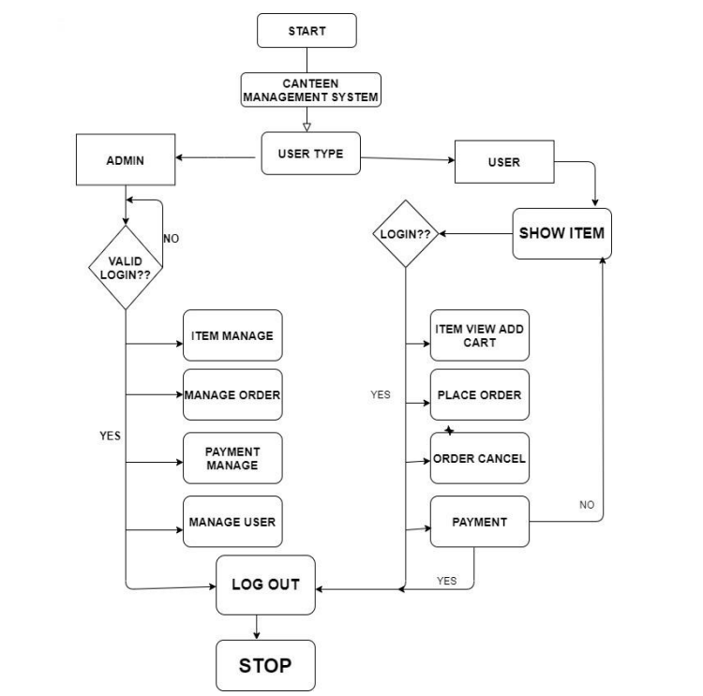

**Fig.1.** Proposed model

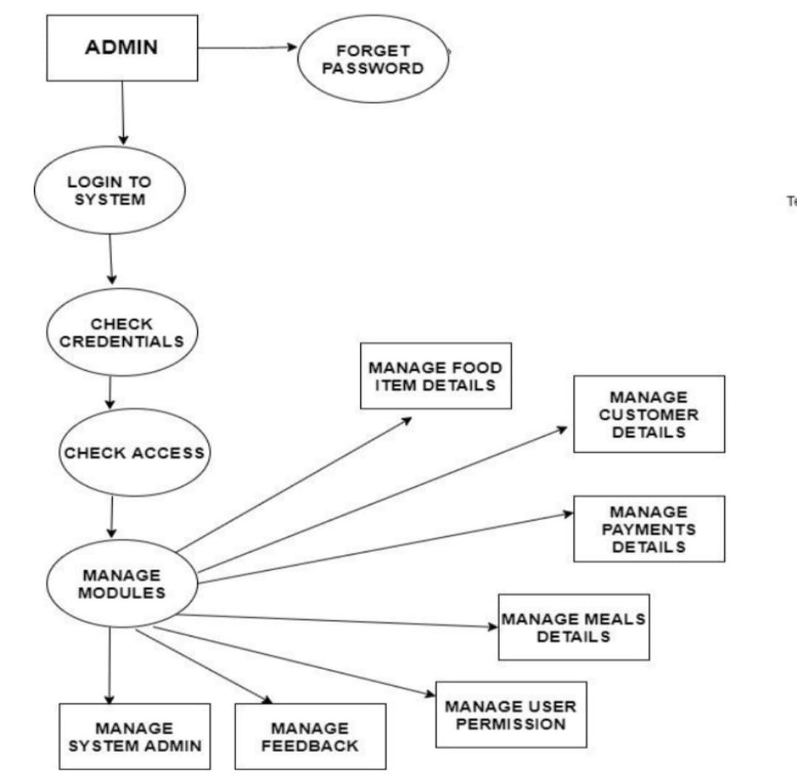

**Fig.2.** Data flow diagram

**CHAPTER 4.**

**OBJECTIVE & SCOPE OF THE PROJECT**

### Objective

* To simplify and automate the daily operations of a canteen or cafeteria, reducing waiting time and improving customer experience.
* To provide an easy-to-use ordering system for customers, allowing them to customize their food choices and track their order status in real-time.
* To enable canteen owners to manage their menu items, pricing, inventory levels, and employee schedules efficiently.
* To streamline the billing process, generate accurate bills, and maintain a record of all transactions.
* To reduce the workload of canteen employees, allowing them to focus on providing quality service to customers
* To provide a secure and reliable platform for canteen owners and customers to interact, ensuring the confidentiality of sensitive information.

### Scope of the project

* A mobile app can be developed to provide users with a more convenient way to access the canteen management system, allowing them to place orders and make payments from their mobile devices.
* Artificial Intelligence (AI) integration: AI can be integrated into the system to provide personalized recommendations to users based on their order history and preferences.
* IoT-based systems can be integrated into the canteen management system to provide real-time monitoring of food inventory and sales, allowing for better supply chain management.

## CHAPTER 5. RESULTS

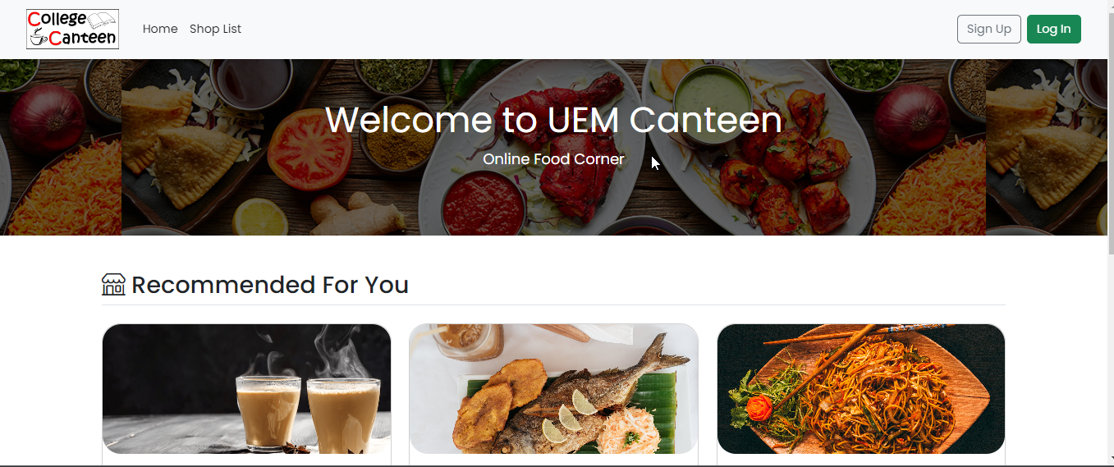

**Fig.3.** Home page

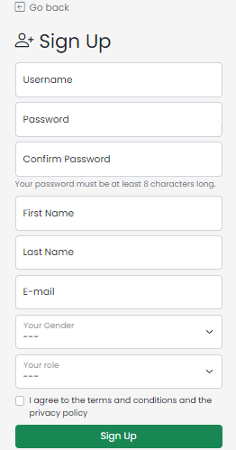

**Fig.4.** Sign Up Page

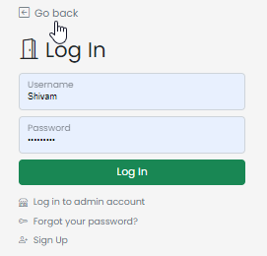

**Fig.5.** Login Page

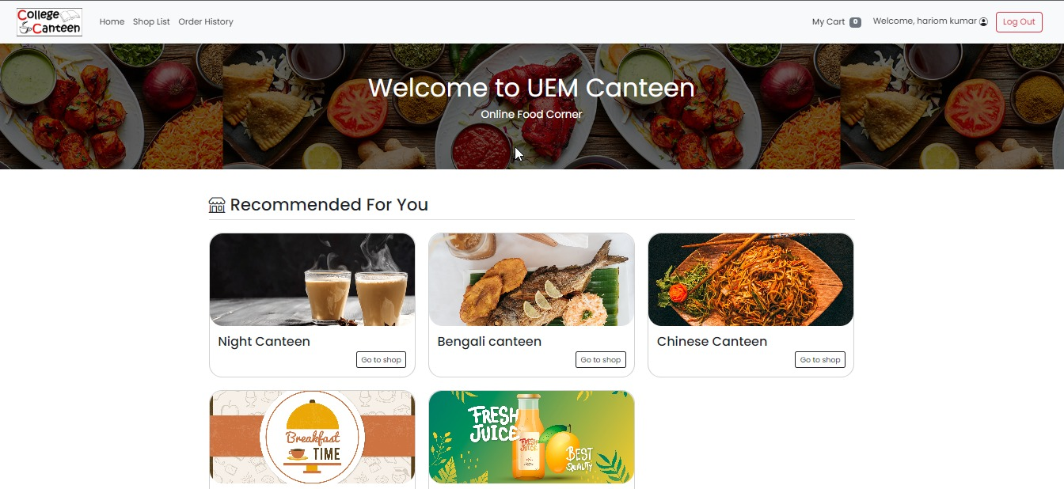

**Fig.6.** User Dashboard

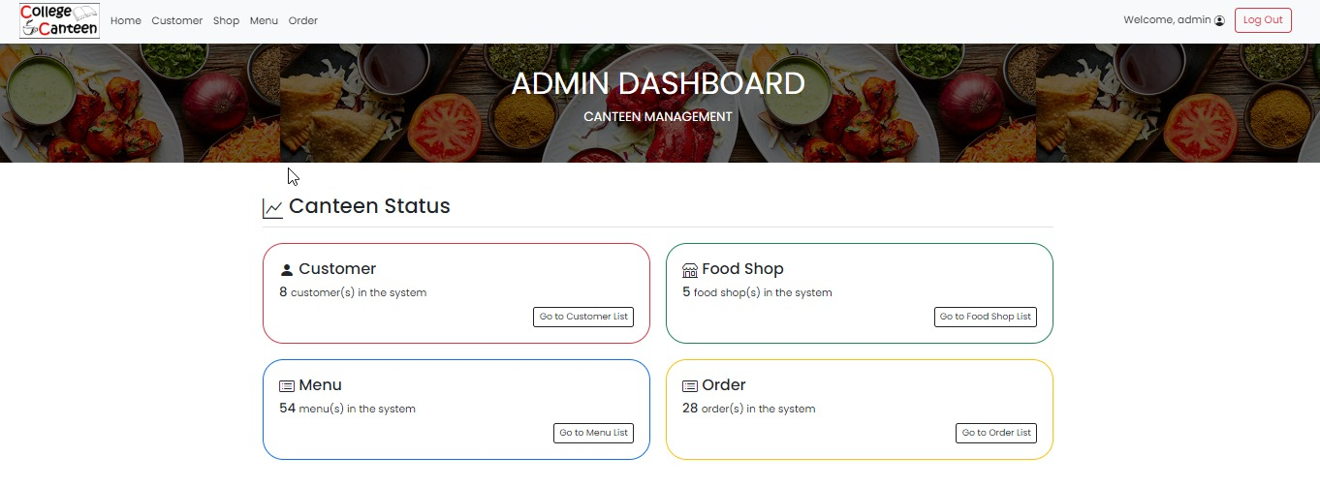

**Fig .7** Admin Dashboard

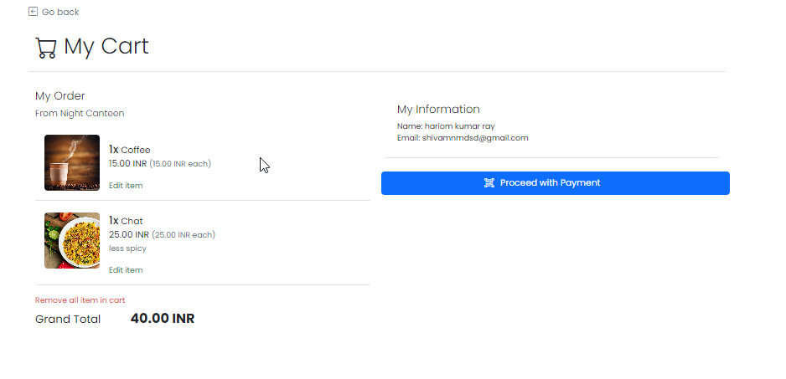

**Fig.8** My Cart Page

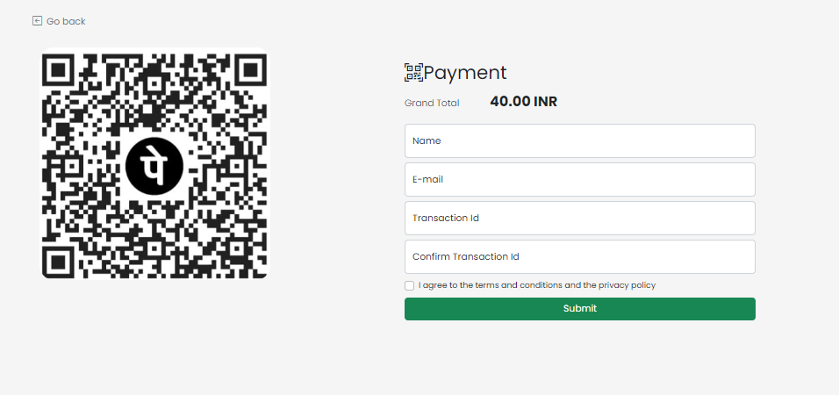

**Fig.9** Check Out Page

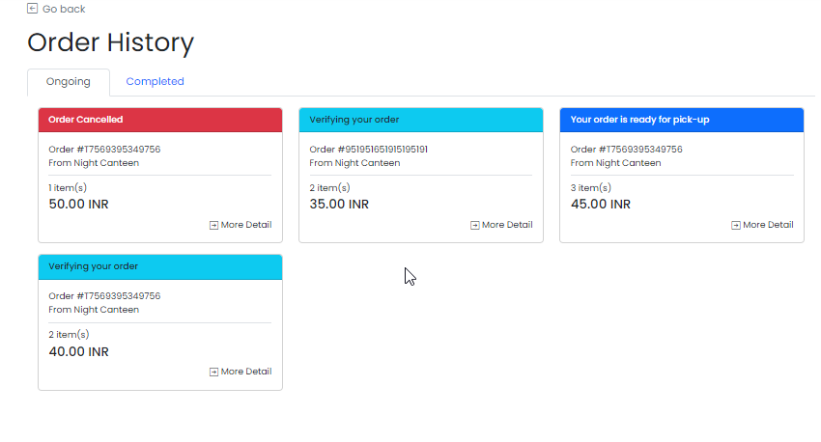

**Fig.10** Order History page

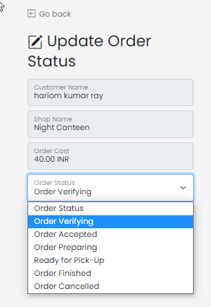

**Fig.11** Order Updation by Admin

**CHAPTER 6.**

**CONCLUSION AND FUTURE SCOPE**

In conclusion, a canteen management system project can bring several benefits to organizations or campuses, such as increased efficiency, improved user experience, and better financial management. However, it is important to consider the potential limitations of the system, such as lack of scalability, dependency on technology, security risks, lack of customization, cost, and training and adoption efforts. When implemented correctly, a canteen management system can greatly enhance the overall management of a canteen, resulting in a better experience for both the organization and its users.

* A mobile app can be developed to provide users with a more convenient way to access the canteen management system, allowing them to place orders and make payments from their mobile devices.
* Artificial Intelligence (AI) integration: AI can be integrated into the system to provide personalized recommendations to users based on their order history and preferences.
* IoT-based systems can be integrated into the canteen management system to provide real-time monitoring of food inventory and sales, allowing for better supply chain management.

# REFERENCES

[1].E-Canteen Management System based on web application | IEEE conference ... (n.d.). Retrieved April 6, 2023, from <https://ieeexplore.ieee.org/abstract/document/9767984/>

[2]. Cashless & Online QR Code based Canteen Management System - irjmets.com. (n.d.). RetrievedApril6,2023,fromhttps://www.irjmets.com/uploadedfiles/paper/volume3/issue_3_march_2021/6833/1628083291.pdf

[3].Ahmed, H. M. F. A., Indap, J. P., Churchill, K., & Jayawant, V. V. (n.d.). *E-canteen ordering system: Food Delivery Software*. International Journal of Software Computing and Testing.RetrievedApril6,2023,fromhttps://computers.journalspub.info/index.php?journal=JSCT&page=article&op=view&path%5B%5D=687

[4].Cheif, I. J. R. A. R. editor in. (2019, March 1). Cloud based Android app for College Canteen Management System. IJRAR. Retrieved April 6, 2023, from https://ijrar.org/viewfull.php?&p_id=IJRAR19H1144 .